## horizontal line



FCIS ASU

SP Project (2017 / 2021)

ToDo List

__________________________________________________________________________________________

**Professor :** Sally Saad

**T.A :** Marwa Raafat

__________

**Team** **Members :**

1. Shehab Ahmed
2. Abdelrhman Rafaat
3. Ahmed Mostafa
4. Radwa Ayman
5. Shehab Hany
6. Tasneem Mitkees
7. Samir Abo El Haggag

## horizontal line

**Purpose :** The software help you to save your Daily Task’s Title , details , overdue date and priority.

and allow you to display all and overdue and done tasks , edit them , remove them , display tasks that need to be done today and search between your tasks for specific task or check specific task as done task.

User Manual

______________

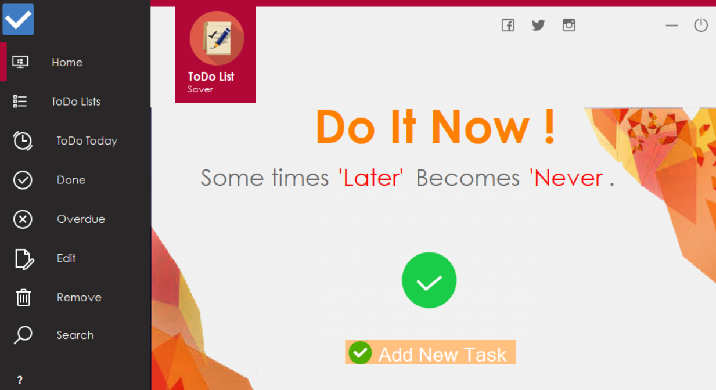

The software consists of eight main buttons.

every button does specific process.

## horizontal line

1. **Add new task button**

You can add any task you want to your tasks list.

when you click on add new task button , a new panel will open.

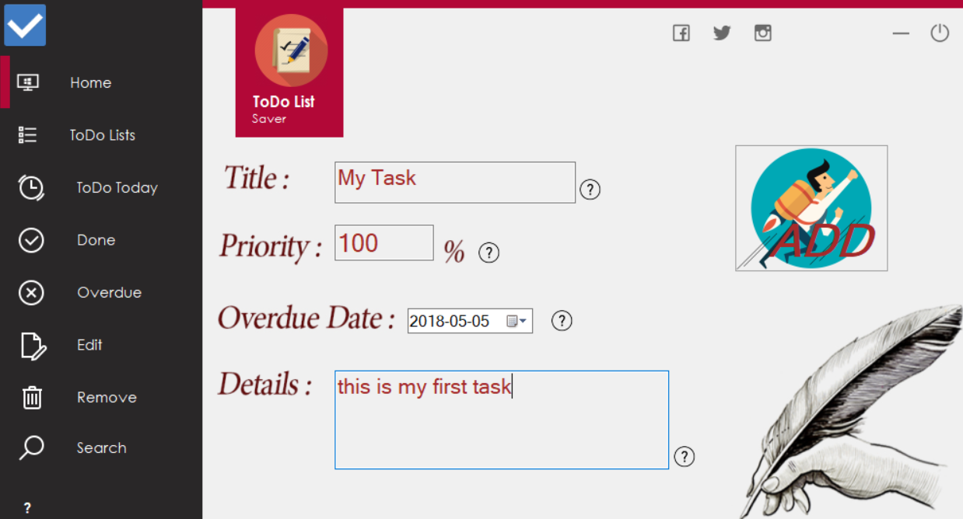

Here you can add your task’s title ,priority, overdue date and details.

Note that you can’t add two tasks with the same title and can’t add any characters or symbols on priority box.

For more info click on question mark icons .

When you click on ADD , your task will save into the database.

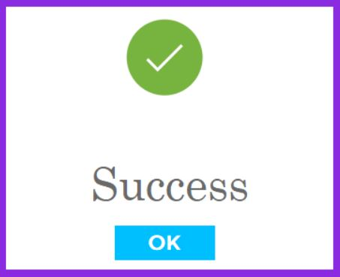

## horizontal line

1. **ToDo Lists button**

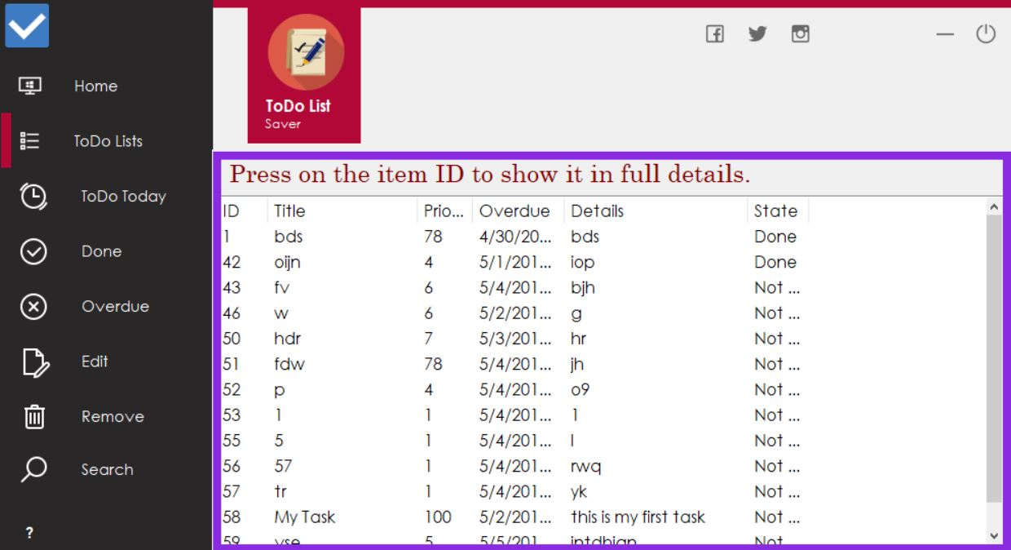

When you click on todo lists you can see all tasks in your database and its info .

note that you can see task’s full info by clicking on that task ID.

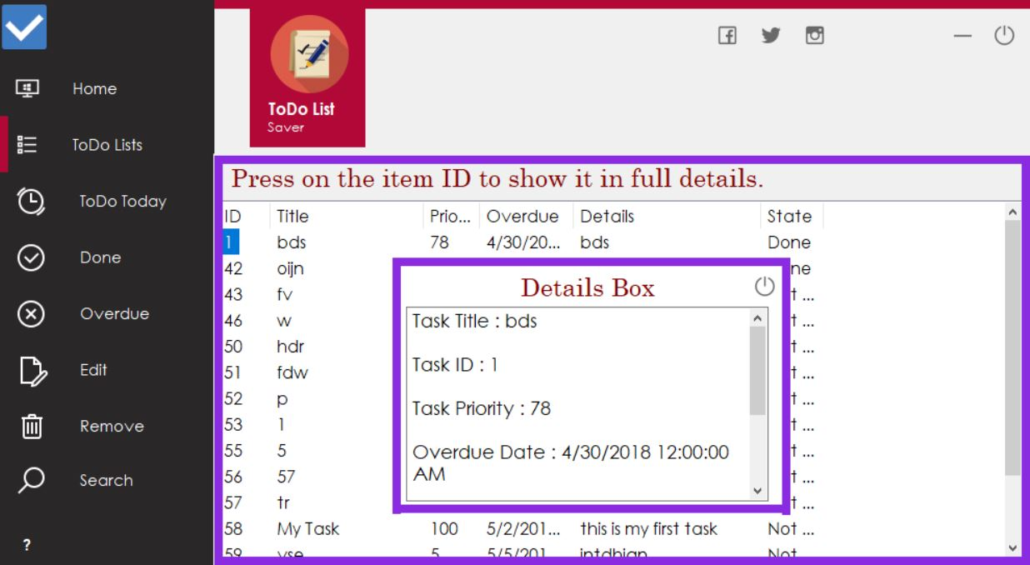

## horizontal line

**3)ToDo Today button**

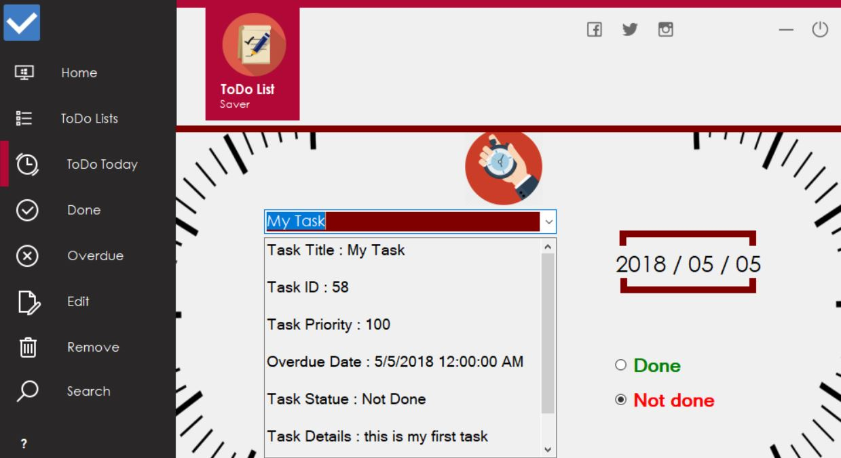

By clicking this button you can see all your tasks that need to be done today.

when you choose specific task from the combo box , all info about this

task will appear with two radio buttons done and not done .

when you check done button , your task will automatically remove from ToDo today lists and checked as done task.



## horizontal line

**4) Done Button**

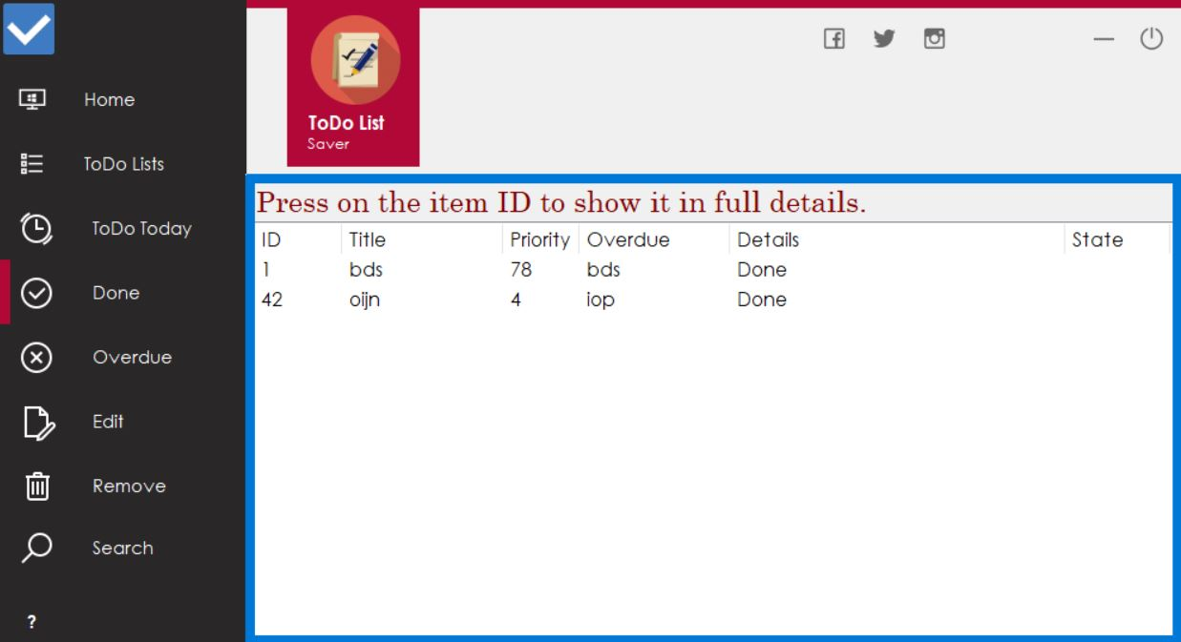

When you clicking done button , you can see all done tasks in your Database .

you can see task’s full info by clicking on that task ID.

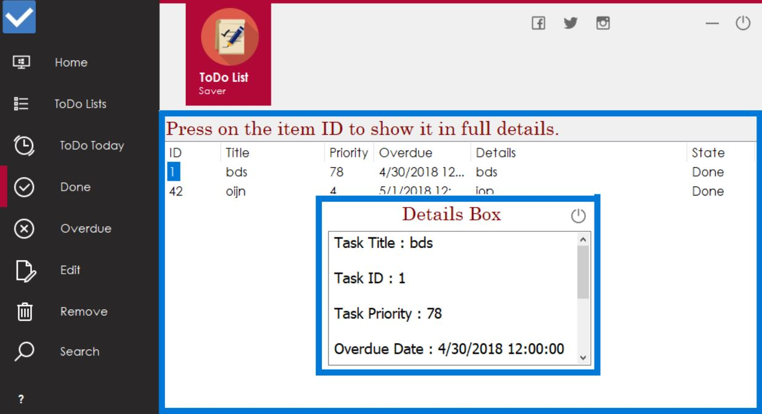

## horizontal line

**5)Overdue button**

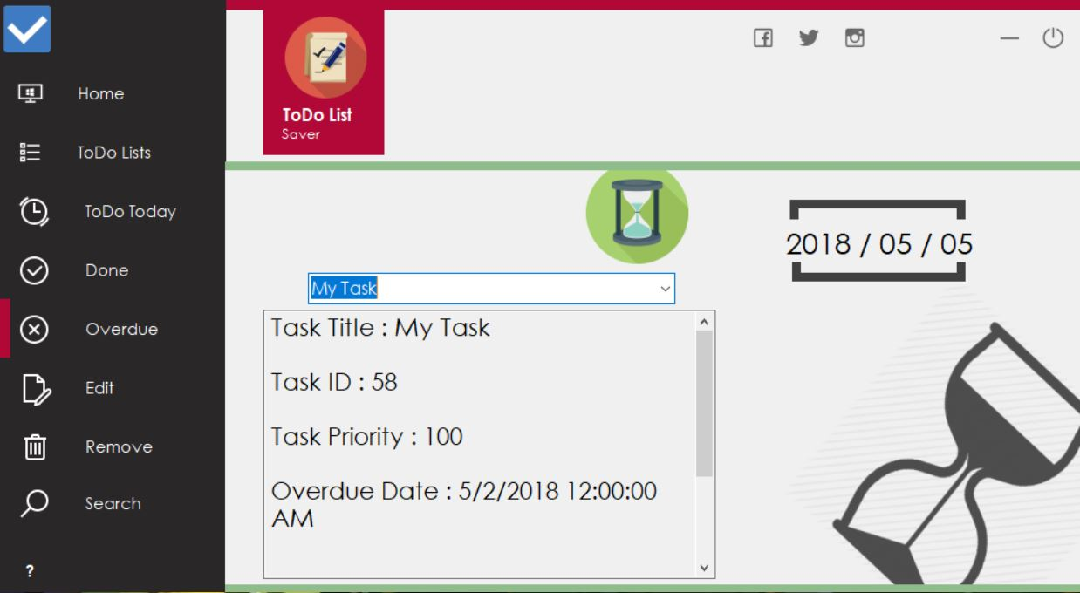

By clicking overdue button you can see all your overdue tasks.

when you choose specific task from the combo box , all task’s info will appear .

## horizontal line

**6)Edit button**

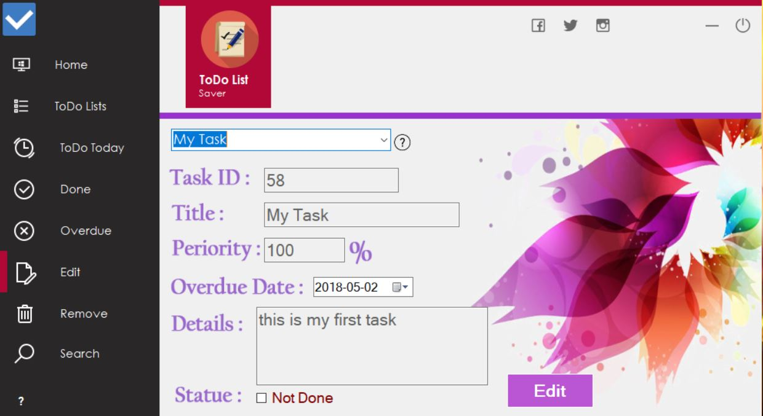

By clicking on Edit button and choose specific task from the combo box , all task’s info will appear in the boxes Below.

you can edit any info about your task including id , title , priority , date ,details and task’s state.

when you click on edit button below , all your task’s info will be update immediately.



## horizontal line

**7)Remove button**

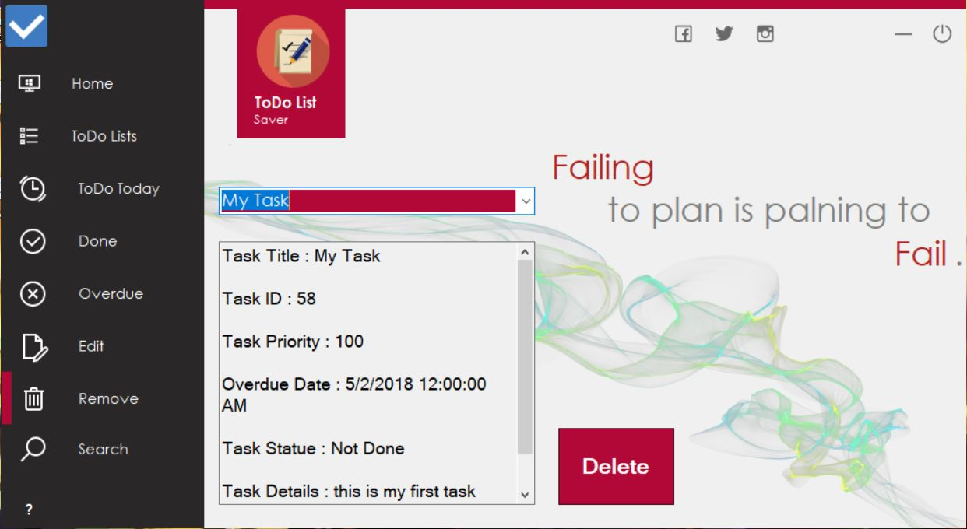

In this button you can remove any task from your database .

when you choose a task , all task’s info will appear below and you can remove it by clicking on delete button .

Note that this task won’t appear on todo lists , todo today , done , overdue , edit or search and remove anymore .



## horizontal line

**8)Search button**

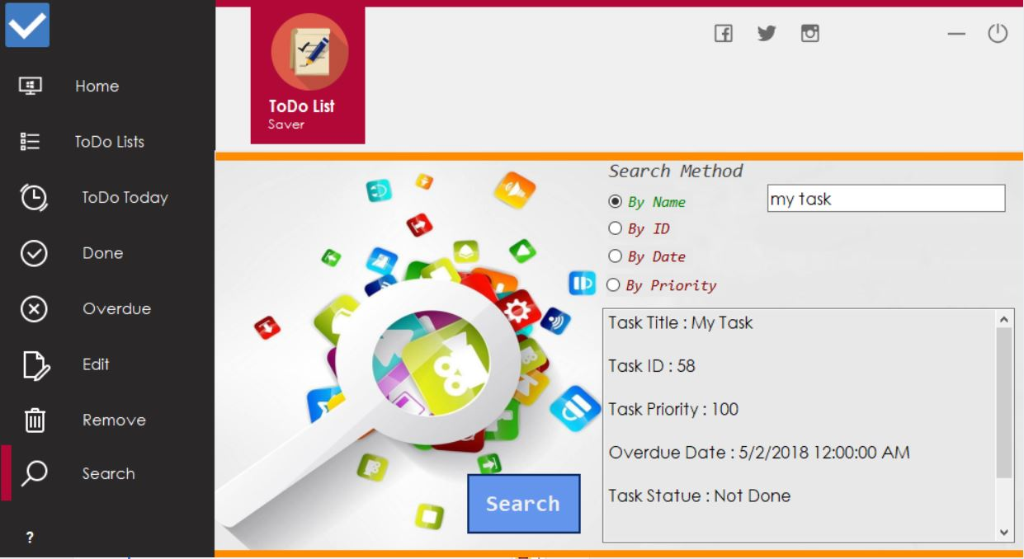

By clicking this button you can search for any task in your database.

First choose search method between four different methods .

after choosing one , a text box or date box will appear ,

type your task name , id , date or priority then click search to display all task’s info.

Note that if you entered name , id ,date or priority which not exist you, will get an error message.